Dataset 6: Caffeine Condition & Reaction Time

Scenario Overview
Participants completed a simple reaction time task after consuming no caffeine, a low dose, or a high dose. Mean reaction times (ms) are shown with SE error bars.

Data Summary
Condition | Mean reaction time (ms) | Error / SD
No caffeine | 310 | 10
Low caffeine | 295 | 12
High caffeine | 330 | 5

Figure
Figure 1. Mean reaction time (±1 SE) across caffeine conditions.
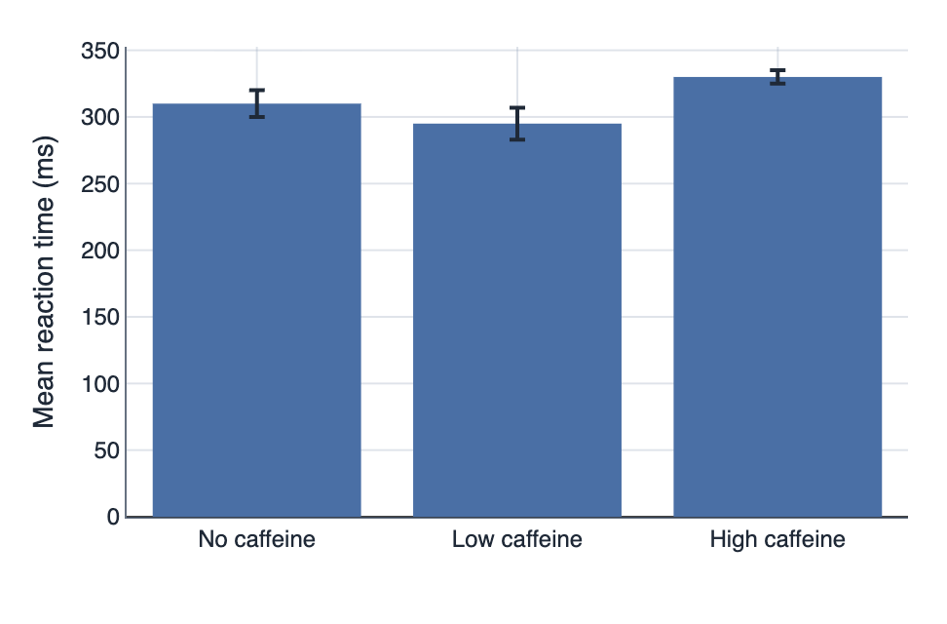

IA1 Practice Questions
- Calculate: Calculate the mean difference between the no caffeine and low caffeine conditions.

- Determine: Determine which condition has the greatest variability.

- Compare: Compare performance across the three conditions.

- Identify: Identify the pattern in the Standard Error (SE) bars between 'No caffeine' and 'Low caffeine' and state what this suggests about the difference.

- Justify: Justify why researchers might choose to display Standard Error (SE) bars instead of Standard Deviation (SD) bars.

- Infer: Infer one evidence-based recommendation for students.

